

**UNIVERSITI TEKNOLOGI MARA**

**SARAWAK**

**CSC318**

**WEP APPLICATION DEVELOPMENT**

Mini Project 1  
Festival Celebration in Japan

Prepared for:

Madam Ketty Chachil

Prepared by:

Aima Aimaduddin bin Bollhasan

(2015812144)

|  |  |  |  |  |  |
| --- | --- | --- | --- | --- | --- |
|  | |  | **Mini Project 1**  **CSC 318 – WEP APPLICATION DEVELOPMENT** | | |
| **Mini Project 1:** | | | | | |
| **Student Name:** | | | | ***5 - Excellent***  ***4 - Very Good***  ***3 - Good***  ***2 - OK***  ***1 - Poor***  ***0 – NA*** |  |
| **Criteria** | ***W*** | | | ***M*** | **W x M** |
| HTML (Consist of all required HTML tags and used accordingly) | **3** | | |  |  |
| Ideas/Contents (Originality) | **2** | | |  |  |
| Layout/Design of web page | **2** | | |  |  |
| Report (presentation, format, quality) | **3** | | |  |  |
| Late Penalty |  | | |  |  |
| **Total marks** | **___**  **50** | | | | |
| **Total** | **/10%** | | | | |
| Lecturer comments: | | | | | |

**Table of Content**

**Contents**

Introduction 4

Objectives 5

Purpose of Developing the Website 6

Reasons Why Choose the Title 7

Screenshots of Website 8

References 15

# **Introduction**

I was given this mini project assignment by Madam Ketty on 28th September 2017. This assignment required us to design a website that are full of information about what are the top 4 festivals in a country that we are freely to choose. I was choosing Japan as a place to find out the best festivals in that country because I heard from my friends that Japan is one of the country that have unique festivals in the world. I decided to give my website’s title “Festival in Japan”.

There are 4 main festivals that I picked to include in my website which is Gion Matsuri, Awa Odori, Kanda Matsuri and Yuki Matsuri. These are the 4 festivals that have the largest number of spectators around the world for every year.

As I go through on the Internet to doing a research about those festivals, I found just a little number of website that provide the information about these festivals. It is quite frustrating because the tourist or people that have desire to visit Japan will face a problem to find the information that they want about the festival.

Because of this matter, I want to create a website that give all the information to the Internet user regarding the top festivals that Japan have right now. This will help the tourist to get information quickly rather than going to any travel agencies or Japan Information Center.

# **Objectives**

There are two mainly objectives why I create this website. The first objective is to give information for the tourist who wants to know about Japan and plan to visit to Japan for upcoming trip. When the website is done, the tourist will be able to know more about occasions in Japan. They don’t have to click or open too many websites just to get what information they want.

The second objective is to make the tourist easier to book a ticket. I have created a form for booking ticket for an event (Gion Matsuri). This will help the tourist or people that want to see the festival to buy a ticket without wasting their time queuing in front of the counter.

# **Purpose of Developing the Website**

The main purpose why I’m developing this website is to gather information that I have researched before and compile it to deliver the information more effectively. I collect all the information from various website and try to classify it according to their type and make it easy to understand by the user.

Next, I want to create an educational type of website. Nowadays, so many websites on the Internet are just for entertainment and didn’t give any benefits for future generation. When there are so many entertainment websites than educational website, the future generation will have no intention to study and to find knowledge.

Finally, I want to promote Japan as a country that people should visit once in their life time. Japan have so many unique festival and culture that we should know and learn. From this website, the Internet users can gain knowledge before they come to a country named Nippon/Japan.

# **Reasons Why Choose the Title**

The reason why I choose this title is because the country that I choose is Japan. The task that had been given to me is to find festival in a country that I choose which is Japan. I had decided to name the title as “Festival In Japan” as my website title.

In this project, I will introduce 4 different festivals that are available in Japan which is Gion Matsuri, Awa Odori, Kanda Matsuri and Yuki Matsuri. These festival is the most popular among the tourist and well known. This website that I created will give information about these 4 festivals such as history of the event, price for the ticket, pictures and many more.

Each festival has their own specialilty. Gion Matsuri’s speciality is we can see Hoko and Yama floats in the air which carry people and spears. For Awa Odori, the special about this festival is it is the largest dance festival in Japan and the “Fool’s Dance” is dance that was created 400 years back.

Special feature about Kanda Matsuri is we can see the Japanese doing a parade with portable shrines name Mikoshi. They will do two parades in weekend that is near May 15. The last one is Yuki Matsuri. Special about this event is we can see sculptures that made with ice measuring 25 meters wide and 15 meters high. The sculptures will be lit up daily until 22:00.

# **Screenshots of Website**

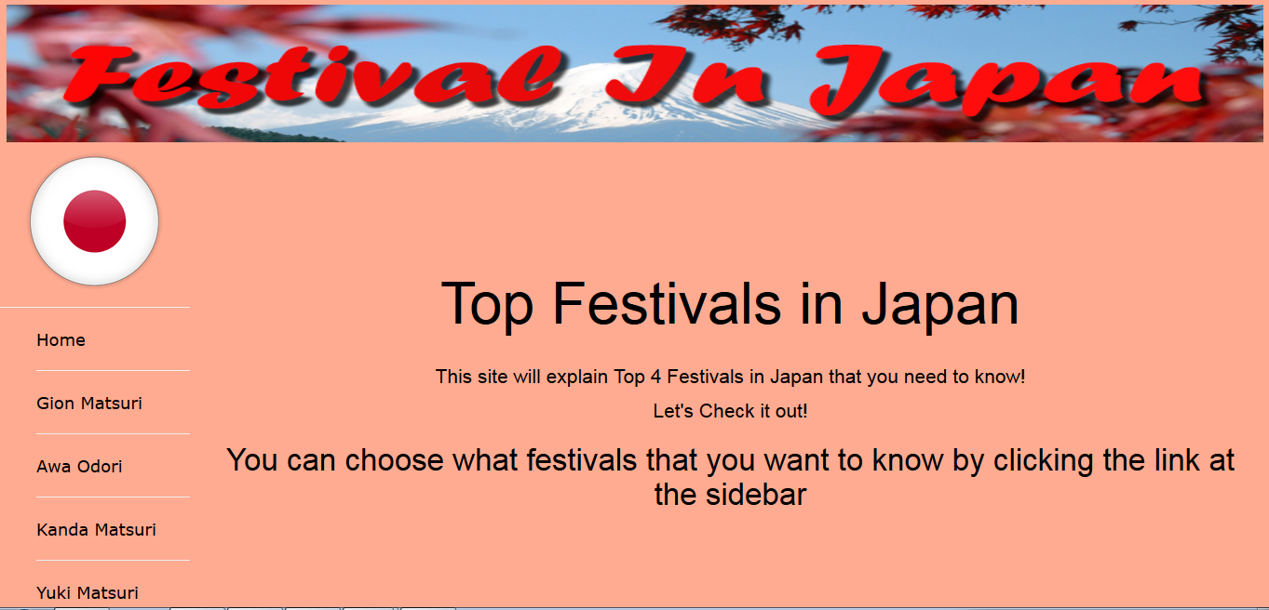

Figure 1Homepage

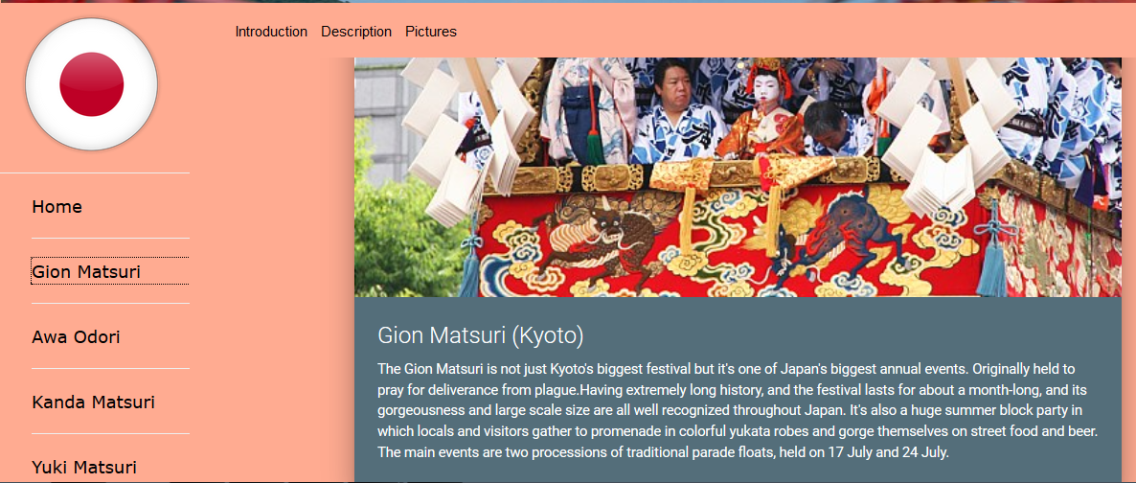

Figure 2 Gion Matsuri (Introduction)

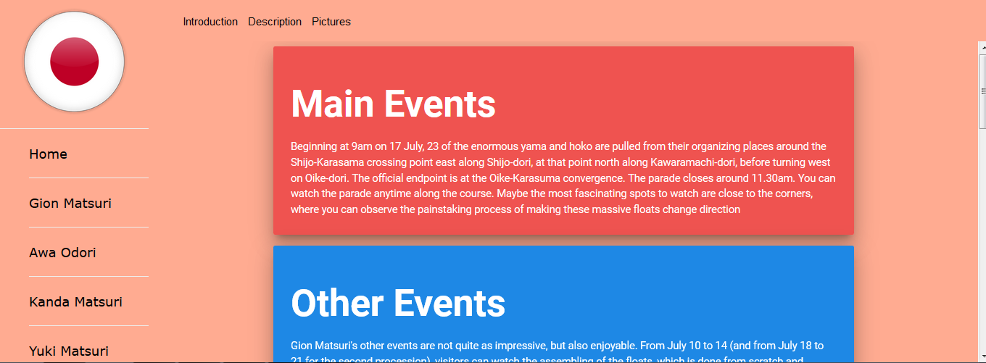

Figure 3 Gion Matsuri (Description)

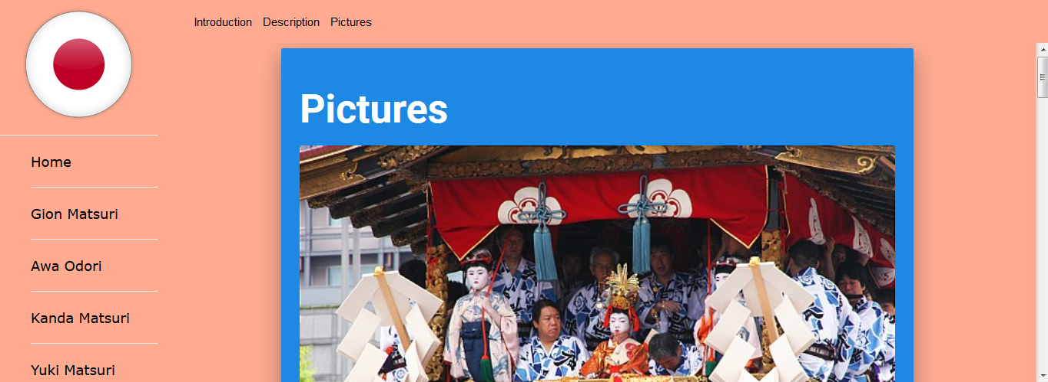

Figure 4 Gion Matsuri (Pictures)

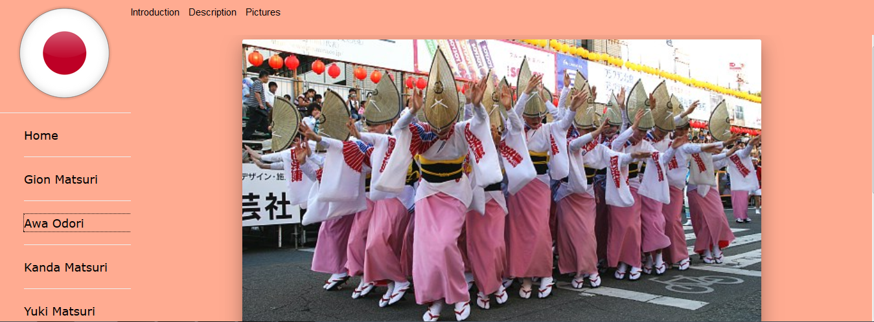

Figure 5 Awa Odori (Information)

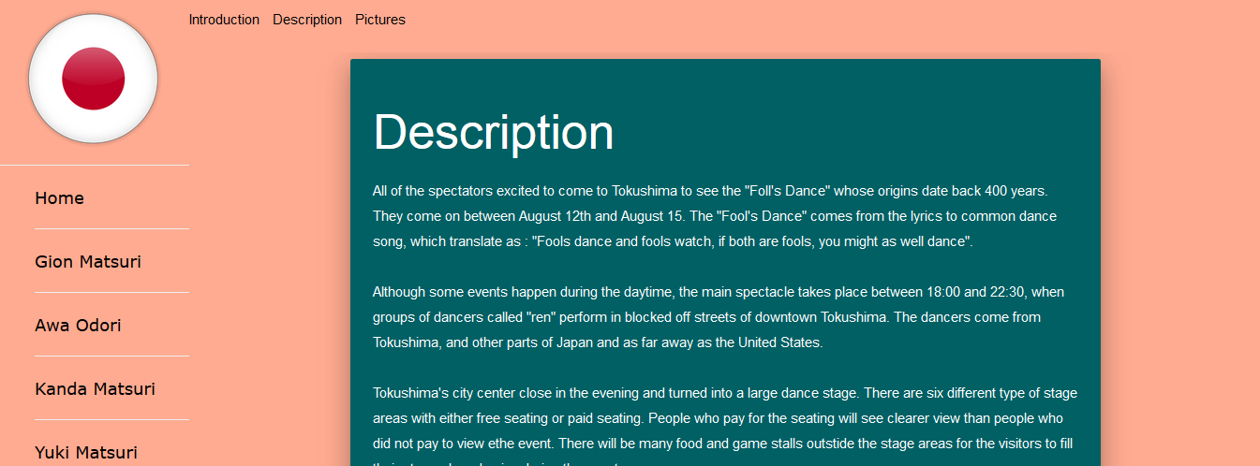

Figure 6 Awa Odori (Description)

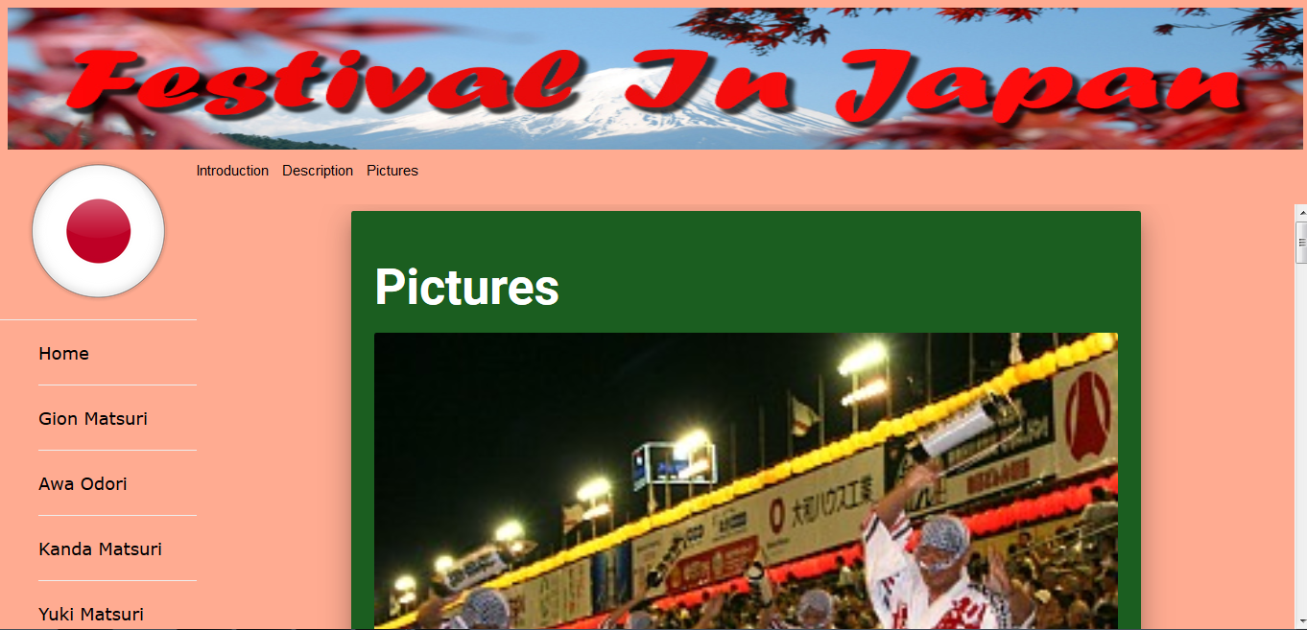

Figure 7 Awa Odori (Pictures)

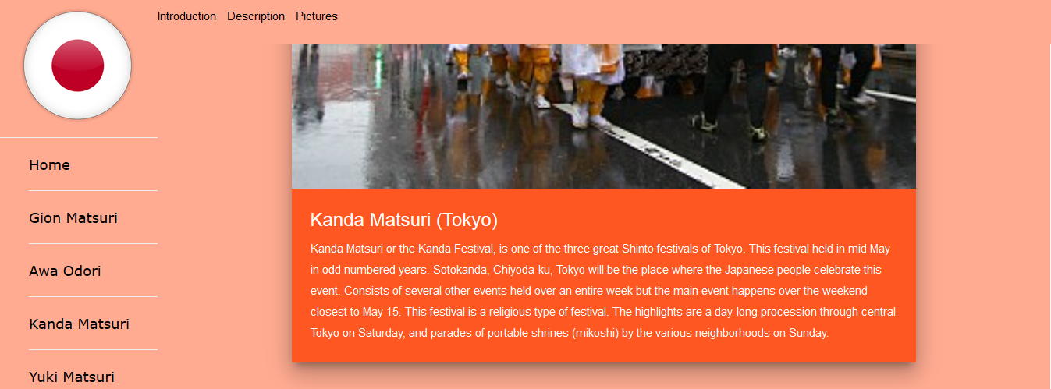

Figure 8 Kanda Mastusri (Introduction)

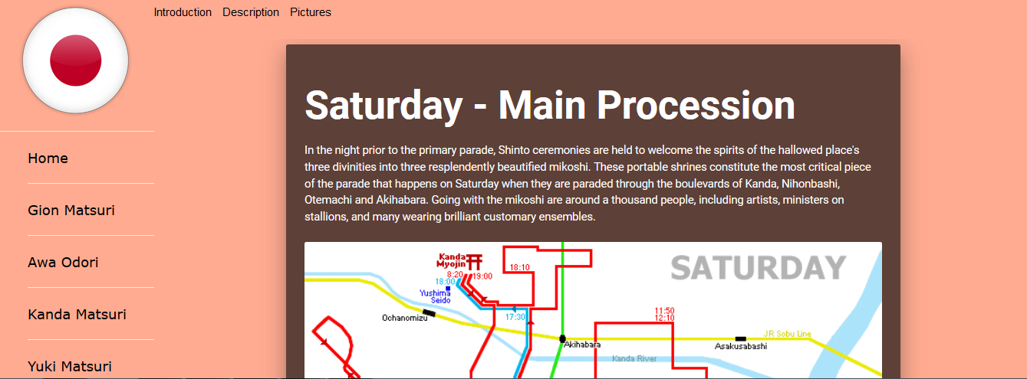

Figure 9 Kanda Matsuri (Description)

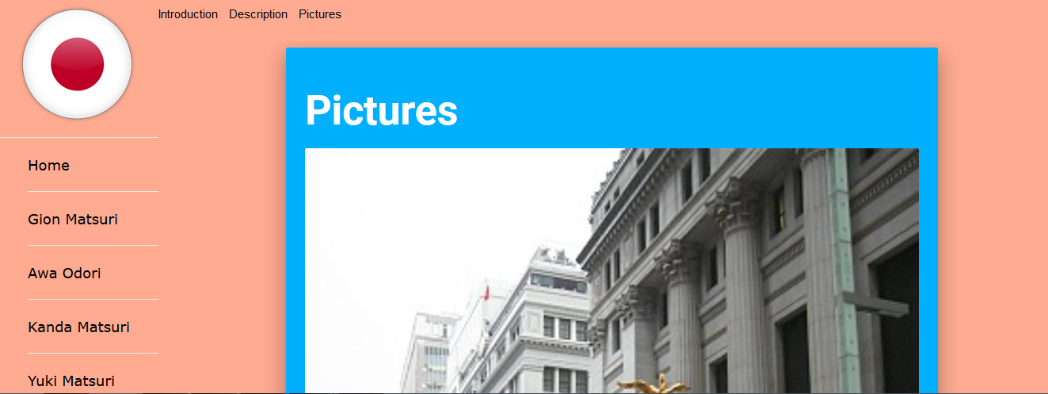

Figure 10 Kanda Matsuri (Pictures)

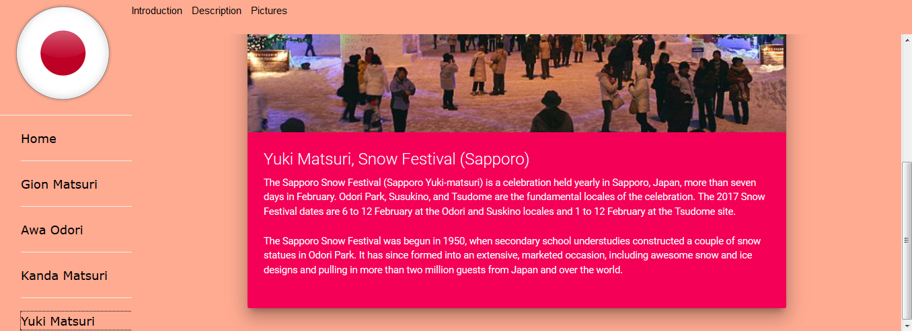

Figure 11 Yuki Matsuri (Introduction)

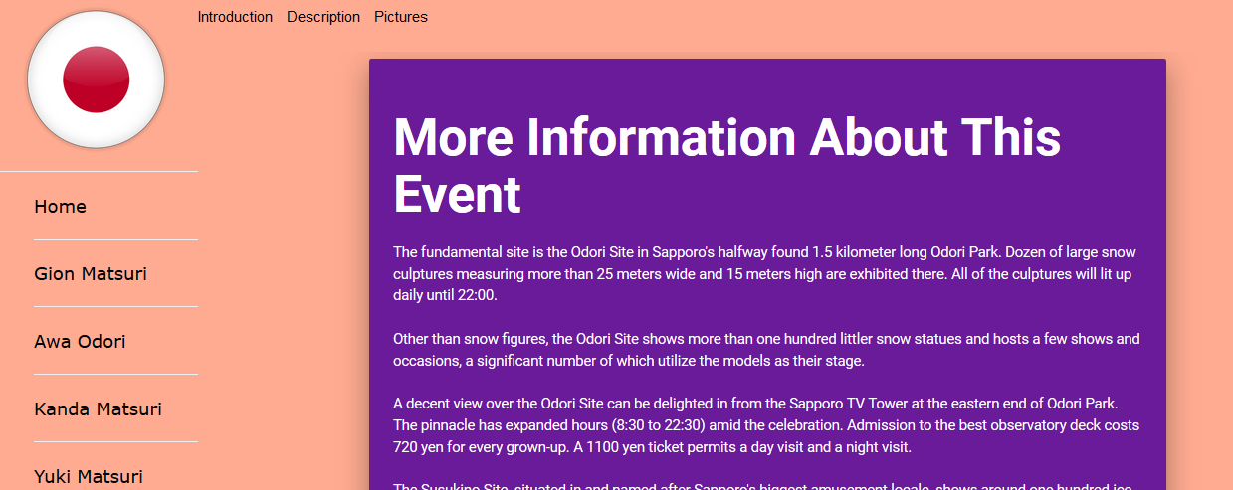

Figure 12 Yuki Matsuri (Description)

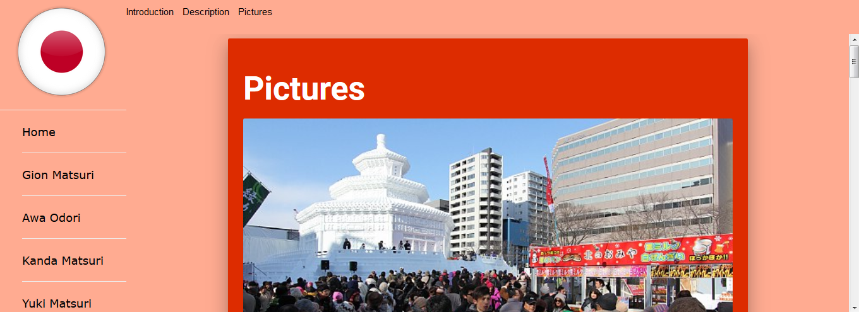

Figure 13 Yuki Matsuri (Pictures)

# **References**

1. <https://www.japan-guide.com/e/e3942.html>
2. <https://www.japan-guide.com/e/e7802.html>
3. <https://en.japantravel.com/tokyo/kanda-matsuri0/4619>
4. <https://www.japan-guide.com/e/e5311.html>
5. http://www.snowfes.com/english/